**Git Commands  
  
1) git clone url**

**2) code.** (If you open it from cloned folder, it will directly redirect to VS code by importing code by default.)

**3) git status**

The git status command is one of the most frequently used commands in Git. It provides a snapshot of the current state of your working directory and staging area, helping you understand what changes have been made, which changes are staged for the next commit, and which files are untracked or ignored.

like if we create a new file which wasn't there previous and then if we run git status will get it as untracked.

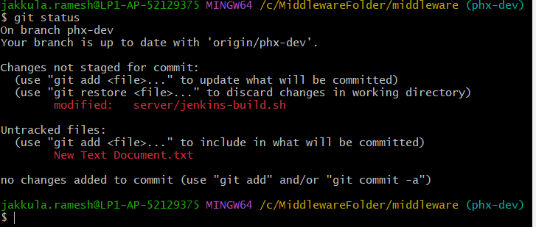

4) **git checkout:**Using -b, you can create a new branch and immediately switch to it:

**git checkout -b new-branch-name**

You can use git checkout to switch to an existing branch.

**git checkout branch-name**

**or**

**git branch newbranchname** : it will create new branch.

**git checkout branchname**: it will switch to respective branch

**git branch -d branchname** :it will delete the respective branch



5) if we use **git add .**

It will add all the changes to the staging area. use if you want to add all files to staging area.

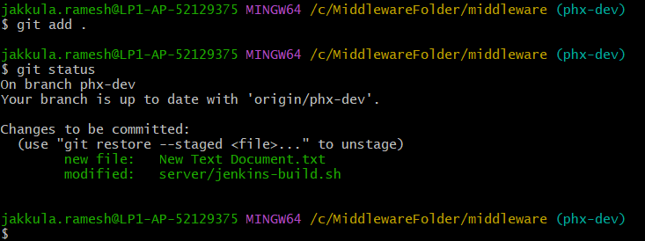

 6) like if we have multiple files but you complete one file then you can use **git add "filename" or git add "filename1" "filename2"**

then it will add only selective file.

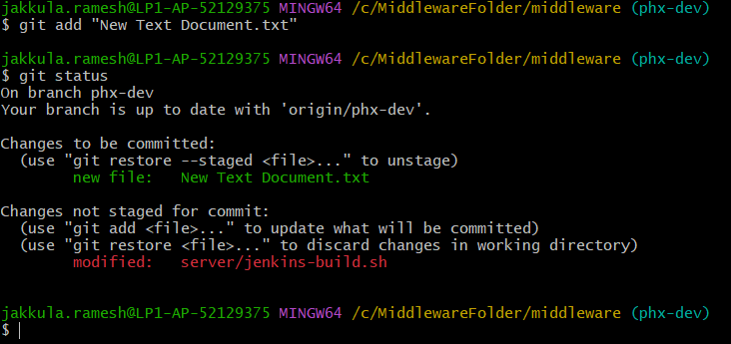

7) If we want to reset or revert all changes from staging area use **git reset**

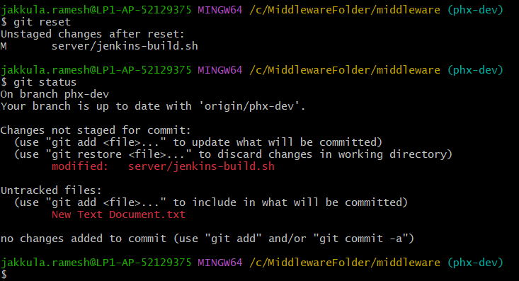

8) If we want to reset or revert specific changes from staging area use **git reset "filename"**

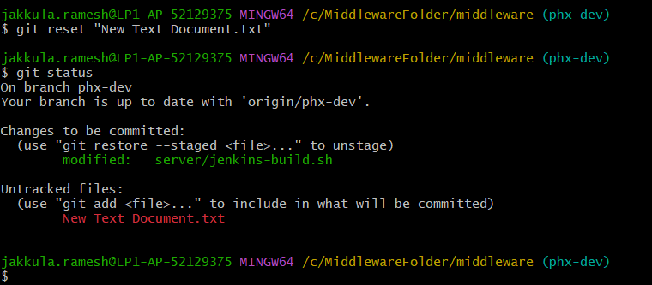

9) **git commit -m "message"**The -m stands for "message."

The git commit -m "message related to change for better understanding" command is used in Git to make a commit with a specific message provided in the quotes after -m. The message should describe the changes made, which helps in tracking history and understanding what each commit does.

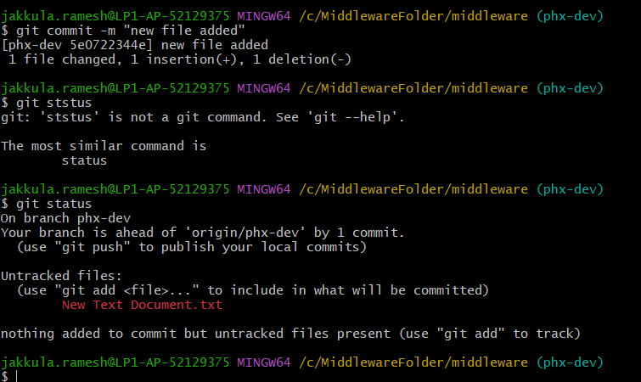

10) **git pull**

The git pull command is used to update your local repository with changes from a remote repository.

It combines two commands: git fetch (to download new changes) and git merge (to integrate those changes into your current branch).

11) **git push**

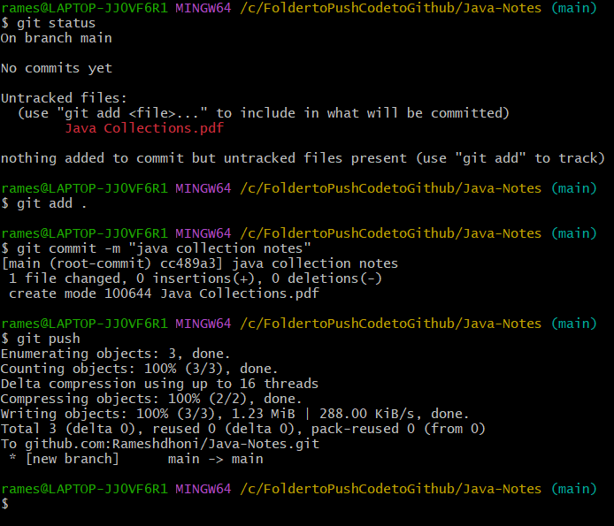

Overview

